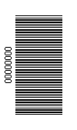 | 

NATIONAL CERTIFICATE (VOCATIONAL)

COMPUTER PROGRAMMING

(Second Paper: Practical)

NQF LEVEL 4

NOVEMBER EXAMINATION

(10041024)

10 November 2014 (X-Paper)
09:00–13:00

This question paper consists of 15 pages.

TIME: 4 HOURS

MARKS: 100

INSTRUCTIONS AND INFORMATION

1.  2.  3.  4. | Answer ALL the questions.  Read ALL the questions carefully.  Number the answers according to the numbering system used in this question paper.  Write neatly and legibly.

INSTRUCTIONS TO STUDENTS AND LECTURERS

1. | Students must be seated in the computer laboratory 30 minutes before the start of the examination to ensure that ALL computers have the appropriate programs.

2. | These questions must be completed on a computer by making use of MS Office 2003 or a later version and VB.NET 2005, VB.NET Express or VB.NET 2008.

3. | Students must make sure that they print their work immediately after having completed a question. Ensure that the EXAMINATION NUMBER appears on each printout. NO QUESTIONS WITHOUT A PRINTED EXAMINATION NUMBER WILL BE MARKED.

4. | In the event of problems such as: a power failure; computer breakdown or printer breakdown the invigilator will make the necessary arrangements for the students to continue with the examination process once the problem has been resolved. Students will not be penalised with time lost under these circumstances.

5. | ALL work on the computer should be saved at regular intervals to prevent loss of work. NO additional time may be allowed for work lost due to lack of saving.

6. | NO student may print his/her work for another student, or make a memory stick available to another student or access another student's work on the network. Any attempt to access any information from or transfer information to another student in whatever manner is a contravention of the examination rules and regulations and will be viewed in a serious light.

7. | ALL printouts or screen prints done during the session must be handed in.

8. | Students may NOT copy the source code from VB.NET to MS Word and then print it from the word processor.

9. | Steps to print a VB.NET form or any other screen:

 | 9.1 | Run the solution.

 | 9.2 | Hold the ALT key down and press the print screen button (This will copy the active screen).

 | 9.3 | Open MS Word and paste the form/screen in a new document.

 | 9.4 | Add your EXAMINATION NUMBER to the top right-hand side of the page.

 | 9.5 | Print the page.

10. | You are allowed to make use of the help files in VB.NET.

11. | The following files will appear on the hard drive in the folders:

 | 11.1 | QUESTION 1  C:\CP L4 P2 NOV 2014\TheAssessment

 | 11.2 | QUESTION 2  Visual Basic solution files:  C:\CP L4 P2 NOV 2014\FreshFruits  The database file is saved in the debug folder of the application:  …\FreshFruits\Bin\Debug\FreshFruits.mdb  A copy of the database file is saved in the folder:  (C:\CP L4 P2 NOV 2014\Database\FreshFruits.mdb)

 | 11.3 | QUESTION 3 & 4  C:\CP L4 P2 NOV 2014\SweggaFashion  delivery.gif; links.gif; swegga.jpg; order.html; styling.css

12. | Students may use the following or any other program of their choice to create web pages:  Notepad++, NetBeans, Adobe Dreamweaver, BlueVoda, etc.

QUESTION 1

The following questions refer to the VB.NET solution called TheAssessment (C:\CP L4 P2 NOV 2014\TheAssessment) that has been saved on the hard drive.

Fundza High School needs to capture learner assessment marks to calculate and determine their academic progress. They have asked you to design an application for them that will calculate the learners' ICASS mark and determine their academic progress.

Below is the IPO chart for the problem.

INPUT | PROCESSING | OUTPUT
StudentNo  Name  Subject  AssignmentMark  FormalTestMark  PracticalMark  InternalExamMark | FinalMark = AssignmentMark * 0.1 + FormalTestMark * 0.1  + PracticalMark * 0.2 + InternalExamMark * 0.6  if FinalMark < 50 then  Rating = 'Not Yet Competent'  else  Rating = 'Competent'  endif | Name  StudentNo  Subject  FinalMark  Rating

FIGURE 1 below is a print screen of what the user interface looks like.

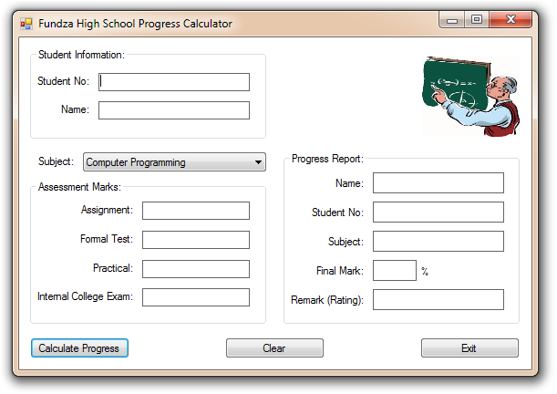
FIGURE 1

The following STEPS explain how to use the program to calculate the ICASS mark and determine the rating of a learner:

STEP 1 | Run the program. Enter the student information, select the subject and enter the assessment marks.

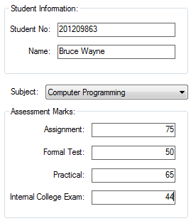

STEP 2 | Click on the Calculate Progress button to calculate the final mark and determine the rating of the student.

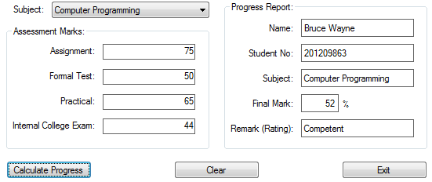

Below is the class diagram for the assessment class. Study the class diagram and answer the questions.

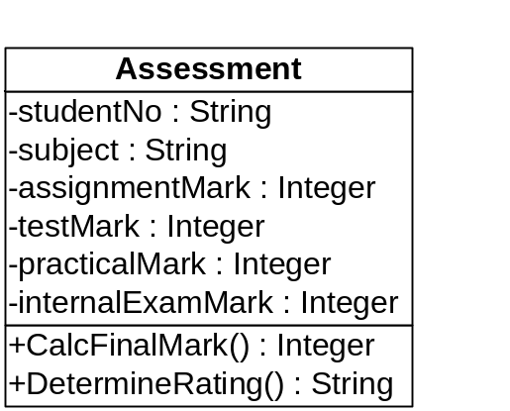

The completed interface with the partially completed program code has been saved on the hard drive. Open the solution TheAssessment and follow the instructions to complete the program.

1.1 | Add the following program code to the assessment class:

 | 1.1.1 | (a) | Declare a private variable/field for the internal exam mark. |  | (1)

 |  | (b) | Create a public property for the internal exam mark. |  | (2)

 |  | (c) | The internal exam mark ranges from 0 to 100. Add error-trapping code that will throw an argumentException from within the property procedure if the internal exam mark falls outside the valid range. |  | (4)

 | 1.1.2 | Create the CalcFinalMark() method for the class. |  | (3)

 | 1.1.3 | Create the DetermineRating() method for the class. |  | (5)

Add your EXAMINATION NUMBER to the program code of the assessment class. Make a printout of the program code of this class.

1.2 | Add the following program code to the click event of the Calculate progress button on the assessment form:

 | 1.2.1 | Create an assessment object. |  | (2)

 | 1.2.2 | (a) | Assign the values from the controls on the form to the appropriate properties of the object. |  | (1)

 |  | (b) | Your code should receive an exception from within the assessment class if the internal exam mark is invalid. Use a <Try ... Catch> block to handle the exception from within the code of the assessment form. |  | (4)

 | 1.2.3 | Invoke the CalcFinalMark() method of the assessment class to calculate the final mark of the learner. Display the final mark in the appropriate label. |  | (1)

 | 1.2.4 | Invoke the DetermineRating() method of the assessment class to determine the rating of the learner. Display the rating in the appropriate label. |  | (1)

Add your EXAMINATION NUMBER to the program code of the assessment form. Make a printout of the program code of this form.

1.3 | Change the text in the title bar of the form to your EXAMINATION NUMBER.

 | Run the program and enter the following test data. Calculate the results and make a printout of the form:  Student No: 201407645  Name: Guybrush Threepwood  Subject: Systems Analysis  Assignment: 75  Formal Test: 56  Practical: 45  Internal College Exam: 53 |  | (1)
 |  |  |  | [25]

QUESTION 2

The following questions refer to the VB.NET solution called FreshFruits (C:\CP L4 P2 NOV 2014\FreshFruits) that has been saved on the hard drive.

FRESH FRUITS is a fresh fruit wholesaler and requested you to design a Visual Basic application for them which they can use to track their fruit sales. They sell many different fruit including apples, bananas, oranges and strawberries.

Each fruit has many different varieties. The different kinds of fruit are captured in one table. The sales figures for each fruit variety are grouped together in a second table.

The VB.NET application will connect to a MS Access database, retrieve and display the content of the database tables.

The database has already been created and is saved on the hard drive in the application folder:

…\FreshFruits\Bin\Debug\FreshFruits.mdb

A copy of the database file is saved in the folder:
...\CP L4 P2 NOV 2014\Database\FreshFruits.mdb

Below is a graphical representation of the two tables (Fruits and FruitSales) and the relationship that exists between the two tables in the database FreshFruits.mdb:

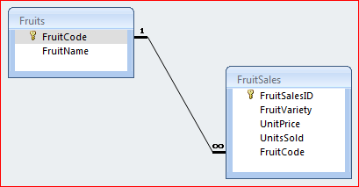

A one-to-many relationship exists between these tables.

The two tables have been created as follows and are populated with data:

TABLE 1: Fruits

Field Name | Data Type | Field Size | Description
FruitCode | Text | 5 Characters | Primary Key (Unique code)
FruitName | Text | 15 Characters | Fruit type e.g. Apples, Bananas, etc.

Below is a sample of some of the records in this table.

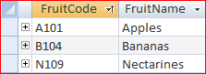

TABLE 2: FruitSales

Field Name | Data Type | Field Size | Description
FruitSalesID | Text | 5 Characters | Primary Key (Unique code)
FruitVariety | Text | 25 Characters | Different fruit varieties
UnitPrice | Currency | 8 Bytes (2 decimal places) | Price per sales unit
UnitsSold | Long integer | 4 Bytes | Number of units sold
FruitCode | Text | 5 Characters | Foreign key

Below is a sample of some of the records in this table.

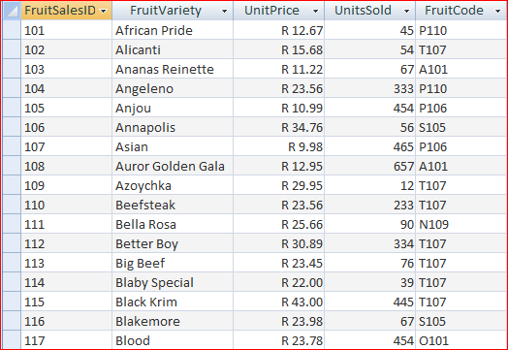

The following STEPS explain how to use the program to display the records from the database tables:

STEP 1 | RUN the program.

The DataGridView is populated with data from both tables. The FruitSalesID, FruitVariety, UnitPrice and UnitsSold columns are populated with ALL the records from the FruitSales table. The FruitName column is populated from the Fruits table. The TotalPrice (UnitPrice * UnitsSold) column is calculated at run time. The records are sorted in ascending order according to the FruitSalesID field.

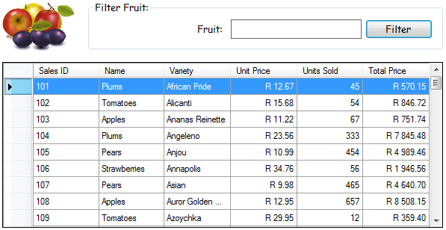

STEP 2 | To filter for any fruit type the user can type the name of the fruit in the fruit text box and click on the Filter button to filter the records accordingly. The FruitVariety field is used to sort the records in descending order.

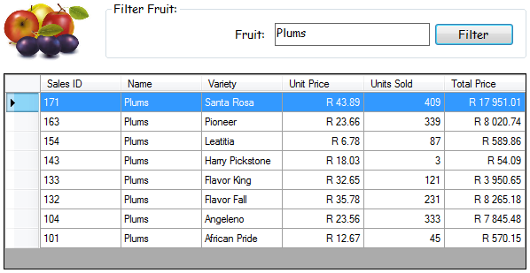

The completed interface with the partially completed program code has been saved on the hard drive. Open the solution FruitSales and follow the instructions to complete the program:

NOTE: | You are required to write a program code and SQL statements to retrieve records from the database tables.

HINT: | Populate a DataTable with records from the database tables. You may use a DataAdapter or Command object.

2.1 | Add the following program code to the GetData subprocedure:

 | 2.1.1 | Write program code to do the following:

 |  | (a) | Establish a connection to the database |  | (4)

 |  | (b) | Retrieve records from the Fruits and FruitSales tables. |  | (4)

 |  | (c) | Terminate the connection with the database. |  | (1)

 | 2.1.2 | Write the SQL statement that will retrieve ALL the records from the FruitSales table to display as set out in STEP 1 above. |  | (8)

 | 2.1.3 | Populate the DataGridView with the resulting records.

 |  | HINT: | Set the DataSource property of the binding source. |  | (1)

 | 2.1.4 | Change the text in the title bar of the form to your examination number.

 |  | Run the program and make a printout of the form. |  | (1)

2.2 | Add the following program code to the click event of the Filter button:

Copy the program code from the GetData subprocedure (QUESTION 2.1) to the click event of this button.

 | 2.2.1 | Rewrite the SQL statement to filter the records as set out in STEP 2 above. Add any program code needed to filter the records. |  | (5)

 | 2.2.2 | Run the program and filter the records to display Oranges. Make a printout of the form. |  | (1)

Add your EXAMINATION NUMBER to the program code of the FruitSales form. Make a printout of the program code of this form.
[25]

You have been asked by Swegga Fashion to create a website for them to enable their clients to view their fashion range online. Clients should also be able to place orders online.

Below is a screen print of the completed webpage (order.html).

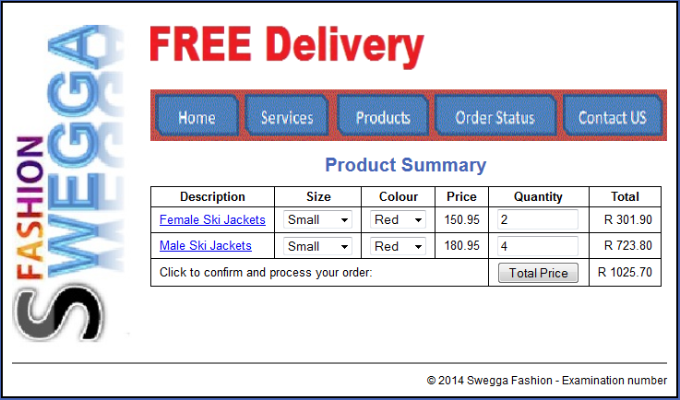
order.html

NOTE: | Use the scenario above to answer both QUESTION 3 and QUESTION 4.

QUESTION 3

The page is divided into six divisions:

- A page division which contains the other divisions.
- A banner at the top of the page, followed by a navigation section
- A sidebar on the left-hand side of the page and the main division on the right-hand side of the page.
- A footer section at the bottom of the page

Copy the following files from the folder: C:\CP L4 P2 NOV 2014\SweggaFasion to your working directory: delivery.gif, links.gif, swegga.jpg, order.html and styling.css.

Save ALL the files in the same directory (HTML, CSS and graphics files).

3.1 | Open the external Cascading Style Sheet (CSS) styling.css.

 | 3.1.1 | Add a rule set for the main division. Set the left margin to 150 pixels. |  | (2)

 | 3.1.2 | Create a rule set for the table element. Set the border of the table element to 1 pixel and make it solid black. Collapse the border. |  | (3)

 | 3.1.3 | Add a rule set for the footer division. Set the top margin to .5 ems. Set the top border to 2 pixels and make it solid gray . Set padding at the top to .7 ems. Clear the footer left. |  | (5)

Add your EXAMINATION NUMBER as a comment to the CSS code. Make a printout of this code.

3.2 | Open the order HTML file and follow the instructions below to complete the webpage for Swegga Fashion:

 | NOTE: | Create ALL divisions inside the page division.

 | 3.2.1 | Add a link to the external style sheet styling.css. |  | (2)

 | 3.2.2 | Create the sidebar division. Add the swegga.jpg picture to the sidebar. Set the height of the picture to 350 pixels and the width to 150 pixels. |  | (3)

 | 3.2.3 | Create the banner division. Add the delivery.gif picture to the banner. Set the height of the picture to 85 pixels and the width to 300 pixels. |  | (3)

 | 3.2.4 | Create the navigation division. Use the links.gif picture to create an image map for the navigation on the page. Set the height of the picture to 56 pixels and the width to 560 pixels.

Use the table below to create the navigation for the webpage:

 |  |  |  | (7)
  Area | Coordinates (x, y) |  | Link to page
  Area | Top Left | Bottom Right | Link to page
  Home | 10,5 | 95,35 | order.html
  Services | 105,5 | 190,35 | services.html
  Products | 205,5 | 300,35 | products.html
  Order Status | 310,5 | 440,35 | orderStatus.html
  Contact Us | 450,5 | 555,35 | contactUs.html

Insert your EXAMINATION NUMBER as the title of the webpage and make a printout of the HTML code.
[25]

QUESTION 4

4.1 | Create a form element inside the main division of the webpage and name it orders. |  | (1)

4.2 | Create the TABLE below inside the form element of the main division.

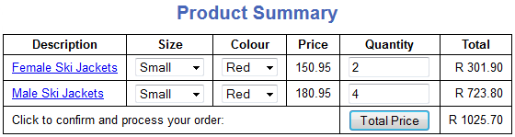

 | 4.2.1 | Add a table element to the form. Add a caption element to the table with the text 'Product Summary'. |  | (1)

 | 4.2.2 | Add the header row to the table with the column headings as indicated above. |  | (1)

 | 4.2.3 | Add the rows for the Female and Male Ski Jackets.

 |  | (a) | 'Female Ski Jackets' and 'Male Ski Jackets' should link to pages female.html and male.html respectively. |  | (2)

 |  | (b) | Create drop-down lists for the size column with values 'Small', Medium' and Large'. |  | (1)

 |  | (c) | Create drop-down lists for the colour column with values 'Red', 'Pink' and 'Black' for female jackets and 'Red', 'Blue' and 'White' for male jackets. |  | (1)

 |  | (d) | The price for female jackets is 150.95 and 180.95 rand for male jackets. |  | (1)

 |  | (e) | Users of the webpage should be able to type in the quantities they want to order. Add the two text fields to the quantity column. |  | (1)

 |  | (f) | The text 'Click to confirm and process your order' should span 4 columns. |  | (1)

 |  | (g) | Add the Total Price button to the quantity column. The button invokes a JavaScript function that calculates and displays the total price for female and male ski jackets and also displays the total price for the whole order. |  | (4)

4.3 | Add a paragraph to the footer division that includes the copyright symbol and the information shown on the webpage with your EXAMINATION NUMBER as follows:  '© 2014 Swegga Fashion - Examination number'  Use the copyright class to display the text. |  | (2)

4.4 | Calculate the totals in the table as follows:

 | 4.4.1 | Add a JavaScript funtion to the web page. |  | (1)

 | 4.4.2 | Calculate the total price for female and male ski jackets. |  | (3)

 | 4.4.3 | Display the total price for the female and male jackets. |  | (1)

 | 4.4.4 | Calculate the total price for the order. |  | (2)

 | 4.4.5 | Display the total price for the order. |  | (1)

4.5 | Launch the page from your web browser and print the page directly from the web browser. Use the same quantities as displayed in the sample webpage. |  | (1)

Make a printout of the HTML code of the webpage.
[25]

TOTAL: |  | 100

